"Kyiv Professional College of Communication"

Cycle Commission of Computer Engineering

REPORT ON THE IMPLEMENTATION

LABORATORY WORK №9

in the discipline: "Operating systems"

Topic: " Securing your system and users in Linux. Create users and groups "

Performed by

student

of BICS-13 group

Zlata Volodymyrivna Los

Checked by the teacher

Sushanova V.S.

Kyiv 2024

**Objectives:**

1. Gaining practical skills in working with the Bash shell.

2. Familiarization with basic actions when creating new users and new user groups.

**Material support of classes:**

1. Computer such as IBM PC.

2. Windows operating system and Virtual Box (Oracle) virtual machine.

3. GNU/Linux OS (any distribution).

4. The Cisco Network Academy website netacad.com and its online Linux courses.

**Tasks for preliminary preparation:**

1. *Read the brief theoretical information for the lab and make a small glossary of basic English terms on the purpose of commands and their parameters.

Administrative Accounts - Accounts that have special privileges to manage and administer the operating system or specific resources. These accounts can have access to run privileged commands, configure system settings, and more that normal users are not allowed to do.

Root User - A special account on UNIX-like operating systems that has the highest privileges. A user with the name "root" has full access to all system resources and can execute any commands and operations, including managing other accounts and system settings.

Root Privileges - Special privileges that the "root" user or other administrative accounts have. These privileges provide access to perform privileged operations and commands that affect the system and its resources.

sudo - The command to execute commands with administrative privileges.

su - Command to switch between users.

User Accounts - User accounts used to identify and authenticate users in the system. Each user has a unique account that allows them to use resources and perform operations within their access rights.

System Accounts - Special accounts designed for use by system services and processes. They are usually not intended to be used directly by users, but are used to perform certain background operations or provide services.

Group Accounts - Group accounts that are used to organize and manage groups of users in the system. Users can be members of one or more groups, which allows you to control access to resources and files.

Primary Group Membership - The primary group to which a user belongs. Each user has one primary group to which they are automatically assigned when they create their account.

Supplemental Group Membership - Additional groups to which a user can belong while working in the system. In addition to the main group, a user can be a member of other groups that provide additional access rights to resources.

Group ID (GID): The Group ID is a unique numeric identifier assigned to each group in the operating system. The GID is used to identify the group in the system and control access to resources such as files and directories.

2. Review the materials in the Cisco Academy NDG Linux Essentials online course:

- Chapter 15 - System and User Security

- Chapter 16 - Creating Users and Groups

3. Take the NDG Linux Essentials course exams on the following topics:

- Chapter 15 Exam

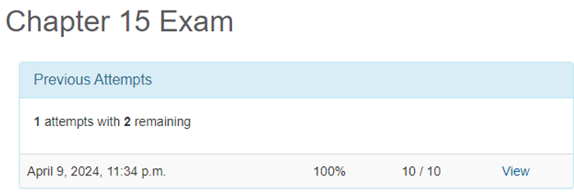

- Chapter 16 Exam

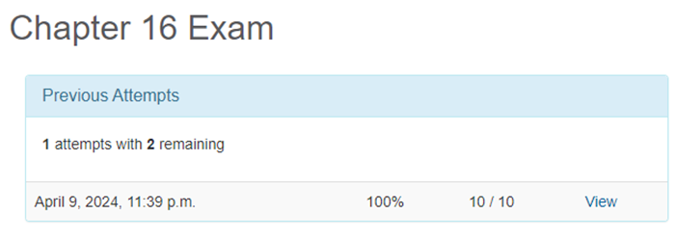

4. Based on the material covered, answer the following questions:

4.1 Explain the concept of UPGs, when is it appropriate to use them?

UPG or User Private Group is a concept used in some Linux distributions such as Ubuntu, Fedora, etc. The main idea is that a separate group with the same name as the user is automatically created for each new user.

When it is advisable to use UPG:

- Security: UPG contributes to security by ensuring that users have their own isolated groups that are more difficult for other users to access.

- Access control: UPG allows you to control access to files and resources belonging to specific users through their own private groups.

- Convenience: UPG makes managing users and groups easier and more convenient for system administrators, as they can more closely control access to resources.

- Process isolation: Each user has their own private group, allowing them to isolate file resource isolation processes and interact with other users and processes.

4.2 *What commands can be used to create user groups? Give examples.

You can use the groupadd command to create user groups. For example:

sudo groupadd mygroup

This command will create a new user group named mygroup.

4.3 **What commands can be used to change the settings of user groups? Give examples.

To change the settings of user groups, you can use the groupmod command. For example:

- To change the name of a group: sudo groupmod -n newname oldname

This command will change the group name from oldname to newname

- Change the group identifier (GID): sudo groupmod -g 1001 mygroup

This command changes the group ID of mygroup to 1001.

5. Prepare an initial version of the report in electronic format:

- Cover sheet, topic and purpose of the work.

- Glossary of terms.

- Answers to p.4.1 and p.4.5 from the preliminary preparation tasks.

**Procedure:**

**1. Initial work in CLI mode in the Linux OS of the Linux family:**

1.1. Start the VirtualBox virtual machine, select CentOS, and start it. Log in to the system as a user: CentOS, login password: reverse (if you are performing the LP in 401) and launch the terminal.

1.2.Start the Ubuntu_PC virtual machine (if you are performing the PL task through the netacad academy)

1.3.Start your Linux operating system (if you are working on your own PC and have installed it) and launch the terminal.

**2. Work through all the sample commands presented in the labs of the NDG Linux Essentials course - Lab 15: System and User Security and Lab 16: Creating Users and Groups. Create a table to describe these commands.**

|  |  |
| --- | --- |
| **Name of the commands** | **Its purpose and functionality** |
| sudo | Allows users to execute commands with elevated privileges (usually executing commands as root or another superuser). |
| su | Command to switch users. When used with a hyphen (-), it switches the environment context to the user you are logged in as. |
| id | Displays information about user and group identifiers. |
| exit | Exit the current shell or session. |
| head | Displays the first few lines of a file. |
| getent passwd username | Displays information about the user with the specified username from the user database. |
| man 5 passwd | Displays the manual page for the passwd file (usually the configuration file for users and groups). |
| who | Displays information about open user sessions. |
| w | Displays additional information about current users and their activity. |
| last | Displays the history of user logins. |
| groupadd | Adds a new user group. |
| groupmod | Modifies the attributes of a user group. |
| groupdel | Deletes a user group. |
| getent | Displays records from one or more database files. |
| grep | Searches for the specified text in the specified file or data stream. |
| useradd | Creates a new user. |
| usermod | Modifies user attributes. |
| passwd | Changes the password of a user or group. |
| lastb | Displays the history of unsuccessful login attempts. |
| usermod -L | Locks a user account. |
| usermod -U | Unlocks a user account. |
| userdel | Deletes a user account. |

**3. Perform the following practical tasks in the terminal as follows (show screenshots):**

- * display information about the current user in different ways (hint: use the id and grep commands);

- practice the last, w, and who commands in the terminal. Compare the output of each command, what details are missing in each command compared to the others?

- Create two new user groups: super_admins, noob_users, and good_students, and define their identifiers;

- create a new user for each member of your team using the terminal (if you are working alone, just three random users), do not forget to set a password for the new user immediately after creating it;

- Add new users to the new groups you created so that the super_admins and noob_users groups have 2 users each, one of whom is in both groups, and add all three users to the good_students group;

- review the information about the groups and which users are members of them, explain what you see;

- delete the first user you created, see if the information about him/her remains in the groups where he/she was a member;

- Remove the second user, see if the information about him or her remains in the groups where he or she was a member;

- Remove the third user and see if their information remains in the groups where they were a member;

- View information about existing user groups;

- Delete the user groups you created;

- View information about existing user groups.

**Control questions:**

**1. Why are passwords not explicitly stored in configuration files?**

Passwords are not stored explicitly in configuration files for security reasons. If passwords were stored explicitly, anyone with access to the file would be able to access the accounts and use them to gain unauthorized access to the system.

**2. Why is it not recommended to perform day-to-day operations using the root account?**

Using the root account for day-to-day operations is not recommended for security reasons. The root account has full access to all system resources, so if an attacker gains access to such an account, they can do damage or change system settings.

**3. *What is the difference between su and sudo mechanisms for obtaining special privileges?**

The main difference between the su and sudo privilege mechanisms is that su (substitute user) allows the user to change their user ID to the one specified (usually root), and sudo (SuperUser Do) allows users to execute individual commands with elevated privileges without leaving their account.

**4. *Why isn't the root user's home directory in the /home directory?**

The root user's home directory is usually placed in /root, not /home, in order to distinguish it as a separate system administrator account and separate it from other users.

**5. what is the getent command used for?**

The getent command is used to retrieve information from various system databases, such as the user, group, host, etc. database.

**6. *How can I change the user password?**

You can change the user password using the passwd command, for example: passwd username, where username is the user's name.

**7. **How can I delete existing user groups? Will information about them remain somewhere in the system?**

To delete existing user groups, you can use the groupdel command, for example: groupdel groupname. Information about groups is usually stored in the /etc/group file.

**8. **What is the purpose of the chage command?**

The chage command is used to change the password change date settings for a user, such as password expiration date, etc.

**9. **What are the most commonly used parameters of the usermod command?**

The most used options of the usermod command are -c (change comment), -d (change home directory), -e (change account expiration date), -g (change main user group), -G (add user to additional groups), -l (change username) and -u (change user UID).

**Conclusion:** I have gained practical skills in working with the Bash shell, and learned the basic steps for creating new users and new user groups.